School of Information Technology
Spring 2016
ITEC 3280 - Assignment

Background
This Assignment is based on MGA’s directory at http://www.mga.edu/directory. The goal is to create a form for data input, validate the data entered, and display it back to the user.

Assignment
- Create an HTML/JS form to capture, validate, and display data similar to the 2 screenshots.
- Add an email field
- First Name, Last Name, Email, Department and Title should be required
- Drop-Down list used for selecting a department
- Only good URLs, email addresses and phone numbers can be entered
- If “Dr.” is checked it should precede the name (last screenshot)
- Email Address and Website should have <a> tag on display-side that can be clicked ‘to go there’
- Should be HTML w3c valid and fully functional
- Individual work only! Outcomes should be unique and fulfill above requirements.

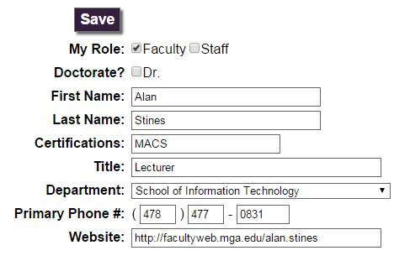

Assignment Grading Policy
- Outcomes should be unique and reflect your design choices
- I encourage you to use the validators to find errors in your code
- https://validator.w3.org/ - I will take off for HTML errors
- http://jigsaw.w3.org/css-validator/ - I will not take off for CSS errors as long as you’re using CSS correctly. Jigsaw is pretty strict IMHO but it can help you find some errors.
- Assignment should fulfill all required elements and be submitted as a .zip or .rar file to D2L Dropbox

